RETURNING TO INDOOR BOWLS

GUIDANCE

Issue 4

24th July 2020

This replaces version 1 which was issued on 29th May 2020,
Version 2 issued on 2nd July 2020 &
Version 3 issued on 20th July 2020

CONTENTS PAGE

Introduction 3
The Aim 3
The Club 4
Playing the Sport 7
The Players 9
The future 9
Key References 10
Appendix One -Entrance & Exit from the rinks 11
Appendix Two -Social Distanced Rink Markings 12
Appendix Three - "T" Moved 13
Appendix Four - Bar/Restaurant Check list 14

Guidance Document for Indoor Clubs
To Prepare for Opening
From 25th July 2020

Introduction

The English Indoor Bowling Association confirm that Indoor Bowls can start again from Saturday 25th July 2020, following the Government’s further easing of COVID-19 lockdown announcement on 9th July.

Therefore, any club wanting to open from this date will have to demonstrate that their facility and bowls activities are COVID secure.

The following guidance document will aid Clubs in making final preparations so that they can ensure that they are able to comply with the conditions associated with being allowed to return to operations.

With regards to conditions on the number of people allowed to participate the Government have stated that for Indoor Sports facilities gatherings of more than 30 people can take place so long as the activity and venue are COVID-19 Secure.

This means that Clubs need to have systems in place to ensure that on every rink used players are 2 metres socially distanced throughout the game. Alternatively, social distancing of 1m with players wearing face covering and standing side by side is permissible, as they are mitigating actions which reduce the risk of transmission.

The Aim

The EIBA in producing this guidance document wants to provide Clubs with areas which need to be focused on and how they can be implemented. Not all Clubs are the same so the implementation will be specific to them, but the requirement to implement procedures is key.

These areas are based upon the Government’s directives as of July 2020 but please note as the COVID-19 situation is going to fluctuate over the next number of weeks / months the EIBA will continue to assess this document and if appropriate re-issue with updated sections.

For ease of planning the Guidance has been split into 3 sections: -

- The club
- Playing the sport
- The players

It is important that Clubs critically assess the requirements and decide that, under the current conditions, whether they are able or unable to open, due to not being able to protect people and or is not financially viable to do so.

The Club

Club management need to critically review and fully complete a COVID-19 risk assessment on how they can set the facility up and play bowls so that they have the legal social-distancing and hygiene measures in place, in order to mitigate the risk of transmission.

This risk assessment should be continually reviewed and updated as the club is used by the Membership.

- Premises

Entrance & Exit

Identify how members are able to enter the club for the start of their game and exit the club afterwards, keeping 2 metres apart or if not feasible 1 metre plus, with mitigating risk procedures: -

Use one door for entry and another for exit. This would allow people for the next session to enter the building safely.

If only one door place 2m distance markings outside and inside to aid the members keeping apart. Also allow sufficient time between sessions so to avoid people entering and exiting at the same time.

Inform all members that they can only enter the building at specific times for their session e.g. 15 minutes before the start and leave immediately afterwards.

Place a sign at the entrance informing members that if they have any of the symptoms listed e.g. persistent dry cough, temperature, loss of taste & smell that they should not enter the building.

Access to and from the rinks (see appendix One)

Identify and appropriately mark how the players can get on and off the green safely.

Limit or remove the number of chairs and tables at the end of the rink in order to give social distancing space.

Changing rooms / Lockers

Changing rooms should be kept closed and be appropriately blocked off and signed.

Players should come dressed to play with their bowls and shoes in a bag which they change into at the rink side. However, if you can put plans in place and actively manage limiting people gathering then lockers could be used.

Consider relaxing dress code so that all players need to bring are bowls shoes to change into.

Toilets

These need to be available but consideration as to how many people can enter at one time, due to space.

May need to operate a one in one out system with appropriate signage to be used to indicate vacant / occupied.

If access is via the changing rooms then block off the changing area and have route to the toilet clearly marked.

Ideally provide paper towels in a dispenser, although hand driers are now permitted as being safe to use.

Display posters about appropriate hand hygiene as a reminder for members to follow.

Toilets should be cleaned regularly, and a schedule of cleaning is prominently displayed.

Bar / Restaurant / Lounge area

From 4th July 2020 any licensed bar and / or restaurant were permitted to open for members to use as long as they are COVID-19 secure and follow the appropriate Government Guidance (this can be viewed by using the specific link listed in the Key Reference Section).

To help you consider if you wish to open the bar and or restaurant please use the sample Checklist, appendix Four.

With regards to the number of people using these facilities at any one time this is governed by how you can mitigate the risk of transmission.

Hygiene

Place hand sanitisers at the entrance, exit and in or outside the toilets and prominent places.

Signage to remind people to wash their hands.

Keep all internal doors open to limit the number of people touching the handles / push panels.

Fire doors will need to remain closed, unless they have a specific fire safety retainer fitted.

Implement a cleaning / disinfectant schedule pre, during and post opening.

In preparation of a member / visitor having coronavirus you should add to your plans what needs to occur as a result: -

- Keep a list of names & contacts (GDPR compliant) for 21 days which can be provided to NHS Track and Trace.

- Closure of the facility until a ‘deep clean’, preferably by a specialist contractor, has been completed. Please refer to the specific link in the Key Reference Section.

Ventilation for the Bowling Green

Ventilation is an important part of mitigating against the transmission of COVID-19. Ventilation into the building should ensure a fresh air supply is provided to all areas of use.

The current design guidance notes (2005) for an Indoor Bowls hall states that this depends on the number of players and or the cooling need, but a rate of 12 litres per second per person is usually considered appropriate. E.g. 8 players per rink x 12 litres = 96 litres compared to 4 players per rink x 24 litres = 96 litres.

The Government, to mitigate the COVID-19 risk are recommending a 100% fresh air supply of 20 litres per person per second.

Please check with your heating / air conditioning engineers or advisers to review your current installation.

The HSE advise that the risk of air conditioning spreading the coronavirus is very low. They do add that if you use a centralised ventilation system that removes and circulates air to different rooms it is recommended that you turn off recirculation and use fresh air supply.

You do not need to adjust other types of air conditioning systems.

The EIBA are continuing investigations in this area and will, when further specific information is received on Indoor bowls venues, release to all Clubs. If you have any queries in this matter please contact the EIBA directly

- Operations

Rink Bookings

Based on the advised number of people who are allowed to play Sport at one time the Club need to implement a pre booking system – no casual walk ups permitted.

Use of on-line booking systems
Via email
Via phone
Or combination of.

This needs to be agreed and communicated to all members along with the timings of sessions, specified arrival time, how many times they can play in a week and timeframe for booking sessions e.g. one week in advance, 4 days in advance.

Keep a list of names & contacts (GDPR compliant) for 21 days which can be provided to NHS Test and Trace.

Payment

All rink fees should ideally be paid by debit / credit cards. If this facility is not available, then investigate how it can be implemented. This could assist payments in the future.

Offer block booking option so the member pays in advance by card or cheque and does not have to deal with payment on the day. Helps social-distancing and removes the handling of cash issue.

E.g. purchase a book of hour session tickets, which are redeemed when playing, which lessens the number of transactions and can alleviate minimum card payment levels.

If not feasible then for cash payments, consider rounding up or down the rink fee to limit number of coins required and have a box at reception which the player can show the steward correct amount and deposit. This can be dealt with later by the staff / volunteer wearing disposable gloves.

There are a number of card payment options listed in the Key Reference Section, which you may wish to investigate, along with speaking to your bank.

Staff / Volunteers

The club has a duty of care to its staff and volunteers who will be in the building at the time. As such a risk assessment should be carried out on the people being asked to work and where they will be working: -

Distance between each working station – remove furniture to achieve and or have people working side by side or back to back but not face to face.

Provide appropriate hand sanitiser in the office / reception space.

Ensure the office space is well ventilated with fresh air.

Ask the personnel to wear a face covering when in the building and provide the appropriate PPE.

Make a decision whether you expect the members to also wear a face covering when in the building. The Government has made the wearing of a face covering mandatory in shops, supermarkets, banks and takeaways from 24th July 2020, but this currently does not apply to other indoor venues, however, people are encouraged to wear face coverings in public places.

If you are using the social distancing of 1 metre, then the players wearing a face covering would provide a mitigating action to reduce the risk of transmission.

Due to the age of the majority of bowls members, who are deemed more at risk, along with others who may have underlying health conditions, it may be appropriate to have the wearing of face coverings as the standard so as to provide confidence for your members to return, as well as the social distancing and hygiene measures implemented.

Investigate placing a Perspex shield at the reception desk, if no glass windows are in situ already.

When bar and catering staff are required, they are provided with face covering and disposable gloves.

Clearly define / allocate roles, what you are asking staff / volunteers to do and monitor effectiveness.

Document when staff / volunteer training has taken place along with who attended.

Playing the sport
Equipment

Mats - They are disinfected before and after use – by club official or player
In multiple player games 1 person from each side e.g. lead nominated to use the mat
A policy of the mat having to be on the ‘T’

Jacks - They are disinfected before and after use – by club official or player
In multiple player games 1 person, e.g. skip from each side nominated to touch the jack.
If sufficient have 1 jack per side
Policy of no jack cast but placed by foot on the nominated length.
Implement re-spotting if jack is displaced towards the ditch / side rinks

Scoring - Decide if rink scoreboards are to be used
If yes 1 player is nominated to operate it with hand sanitiser provided.
If no, use of scorecards only and players need to use own pen and place card in a bin at the end of the game.
Format

With the Government allowing gatherings of more than 30 people subject to the venue and activity being COVID-19 secure, the EIBA advise that you can operate with the following formats of play.

The club will then need to identify how you can safely implement and manage which one and across all of the rinks plus whether it is financially viable for you to do so. (See appendix Two)

The key areas to factor in: -

- Social distancing can be maintained
- Implement robust hygiene procedures for the equipment, players to use their bowls only.

You could consider reducing the width of your rinks to allow more space for Social Distancing and people walking up and down the rink. Whilst COVID-19 secure procedures are required, the EIBA is happy for Clubs to reduce their rink widths to 4m, as per its National Competition Rules.

Single Play

With the dimensions of the rink and how the game is played this is the safest format to be played as distance between players can be easily maintained, across all rinks

Pairs Play

Again, the dimensions of the rink will allow 2 players at each end to have ample space between each other and those players on adjoining rinks.

Clubs may wish to place a suitable mark(s) on the green 2m distance from the ‘T’ to ensure the players can comply to the social distancing.

Consider a policy that all ‘Ts’ are moved up a further 1 or 2 metres to create more space for players behind the mat. (See appendix Three)

Triples Rink Play (Recommended for Clubs to use when first opening)

The four people on or behind the ‘T’ can be at the 2m social distance, either with two off the rink and two on the rink.

For those Clubs who have a wall immediately at the end of the rink they should consider the moving of the ‘T’ to 4m from the ditch. (See appendix Three)

To help allow adjoining rinks to be used, if the club is unsure of the distance between the non-bowlers then operate an alternate start end system.

Fours Rink Play

If you can ensure that six players can maintain social distancing at one end then a standard game can take place.

If not you, would, under COVID-19 conditions, have to ensure that there are only four people at either end and be at the 2m social distance, either with two off the rink and two on the rink.

Non-playing officials

The club to make a policy on whether umpires and or markers will be allowed.

If yes, they should be asked to wear an appropriate face covering and disposable gloves.

With regards to measuring the club makes a policy on whether this takes place during games and by whom.

At this time the EIBA recommend that any coaching is done on a 1:1 basis with the appropriate social distancing in place. We will continue to review this recommendation and advise of any change.

Alternate rink use

If the club deems it more appropriate or as a starting point to have bowls played, by their members’, then this option is the one which will enable Clubs to ensure social distancing is maintained whilst the games are underway.

Walking up and down the rink (see appendix Two)

The club to advise members that they should maintain the social distancing when they are changing ends. Have each team use a dedicated side of the rink, throughout the game.

Monitor how players manage this and Clubs may need to consider having an identifying mark(s) on each side of the ‘T’ to guide players.

The Players

Even though the club will have assessed and implemented plans to ensure the safety / wellbeing of everyone, the successful outcome will be influenced by the members who want to start bowling again.

The club needs to: -
- Communicate its plans to all members, staff, committees etc.
- Get the members acceptance to the plans when they book, if no then no booking allowed.
- Advise / publicise that members who display symptoms should self-isolate as per Govt guidance.
- Display prominently within the club key messages / statements on actions expected
- Continually monitor / review how the plans are working
- Advise members who aren’t complying that they need to or if not will not be allowed access
- Listen to feedback / concerns from staff, volunteers and members.

The future

We all want to see indoor bowls return as soon as it can but only on terms which protects the health and wellbeing of everyone. But ultimately the final decision on whether the club remains closed or operates under these conditions, from Saturday 25th July 2020 remains a CLUB decision.

The EIBA again would stress that due to the COVID-19 still being present in England, then the Government may and / or will change their decision on Indoor Bowls being allowed to be played, across the Country and / or in specific locations. As such if and when there are any amendments or new conditions, we will advise all Clubs as to what actions need to take place.

In the next month the EIBA will issue guidance for Clubs in relation to hosting inter club and county matches along with hosting bowls events such as Open Singles Circuit / PBA Qualifiers.
Key reference documents

Department of Culture, Media & Leisure -

https://www.gov.uk/guidance/working-safely-during-coronavirus-covid-19/providers-of-grassroots-sport-and-gym-leisure-facilities

Guidance for Bars & Restaurants -
https://www.gov.uk/guidance/working-safely-during-coronavirus-covid-19/restaurants-offering-takeaway-or-delivery

Health & Safety Executive - https://www.hse.gov.uk/news/coronavirus.htm

https://www.gov.uk/work/health-safety-at-work

www.hse.gov.uk/coronavirus/legionella-risks-during-coronavirus-outbreak.htm

https://www.cibse.org/coronavirus-covid-19/emerging-from-lockdown

Risk Assessment
https://learn.sportenglandclubmatters.com/pluginfile.php/31273/mod_resource/content/2/Club%20Matters%20-%20Creating%20a%20Risk%20Assessment%20SO.pdf

https://www.hse.gov.uk/risk/assessment.htm

Cleaning
https://www.gov.uk/government/publications/covid-19-decontamination-in-non-healthcare-settings/covid-19-decontamination-in-non-healthcare-settings

Card machine options - https://www.mobiletransaction.org/card-machine-small-business-uk/

ISSUED BY
ENGLISH INDOOR BOWLING ASSOCIATION LTD
24th July 2020

Appendix One

Entrance & Exit from the rinks

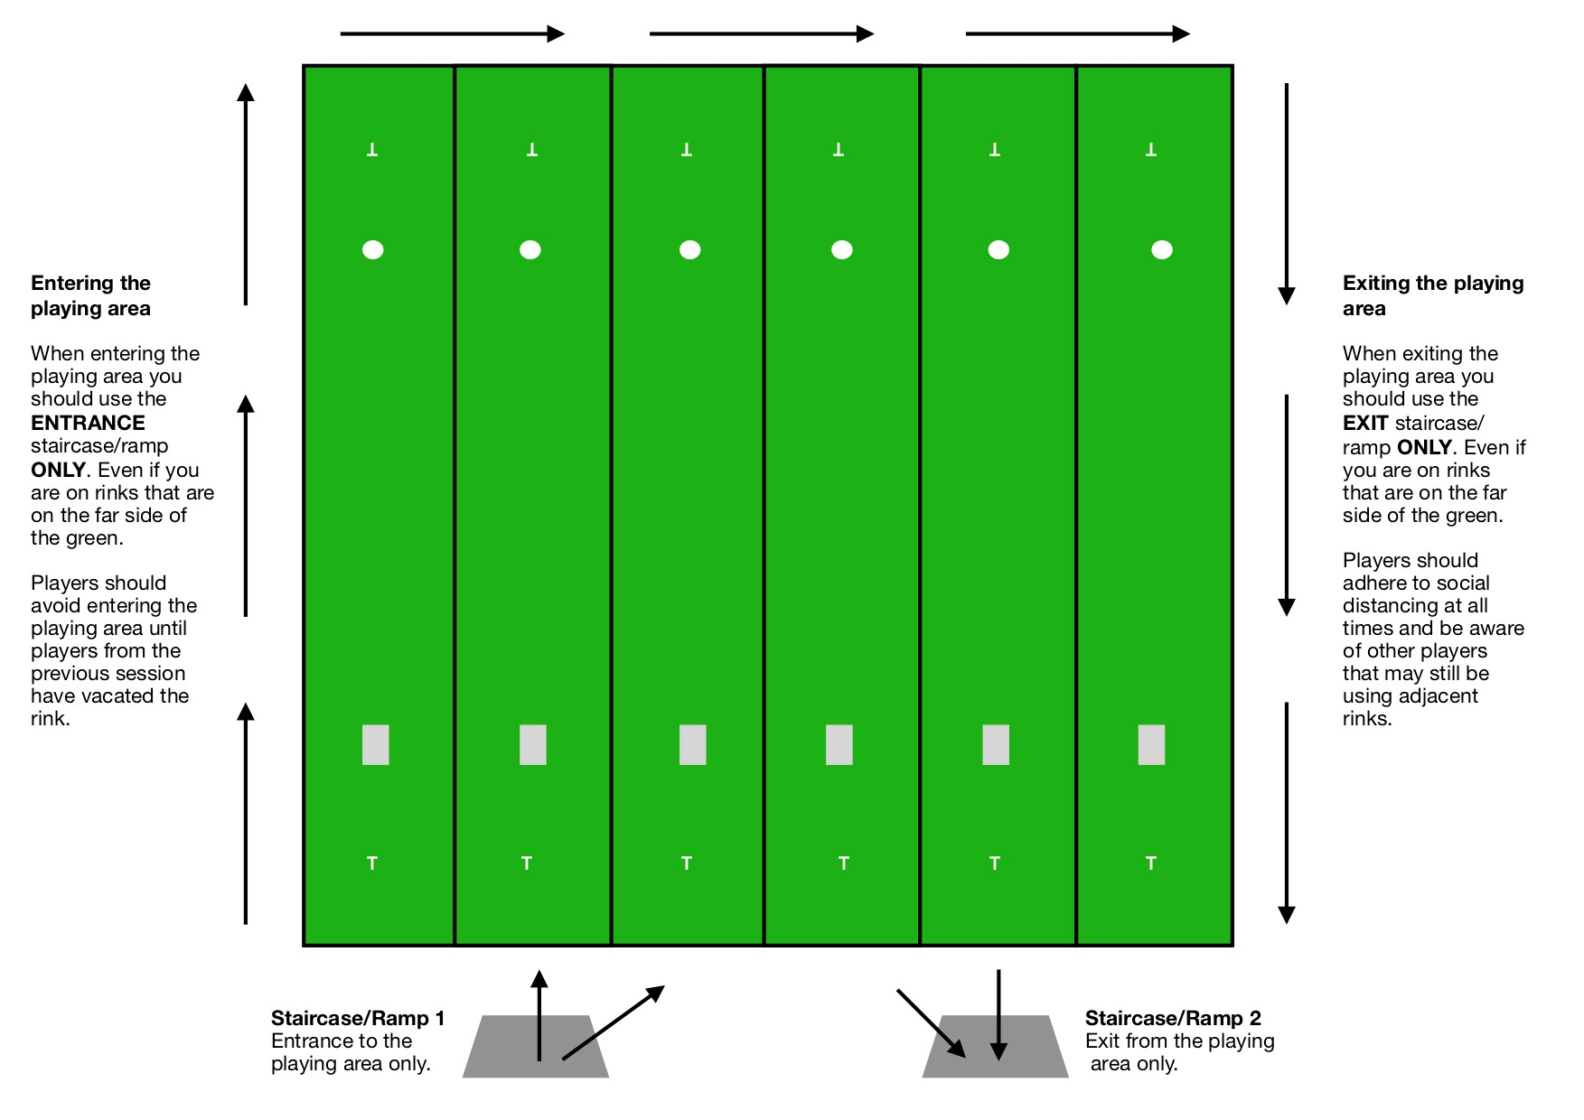

Appendix Two

Social Distanced Rink Markings

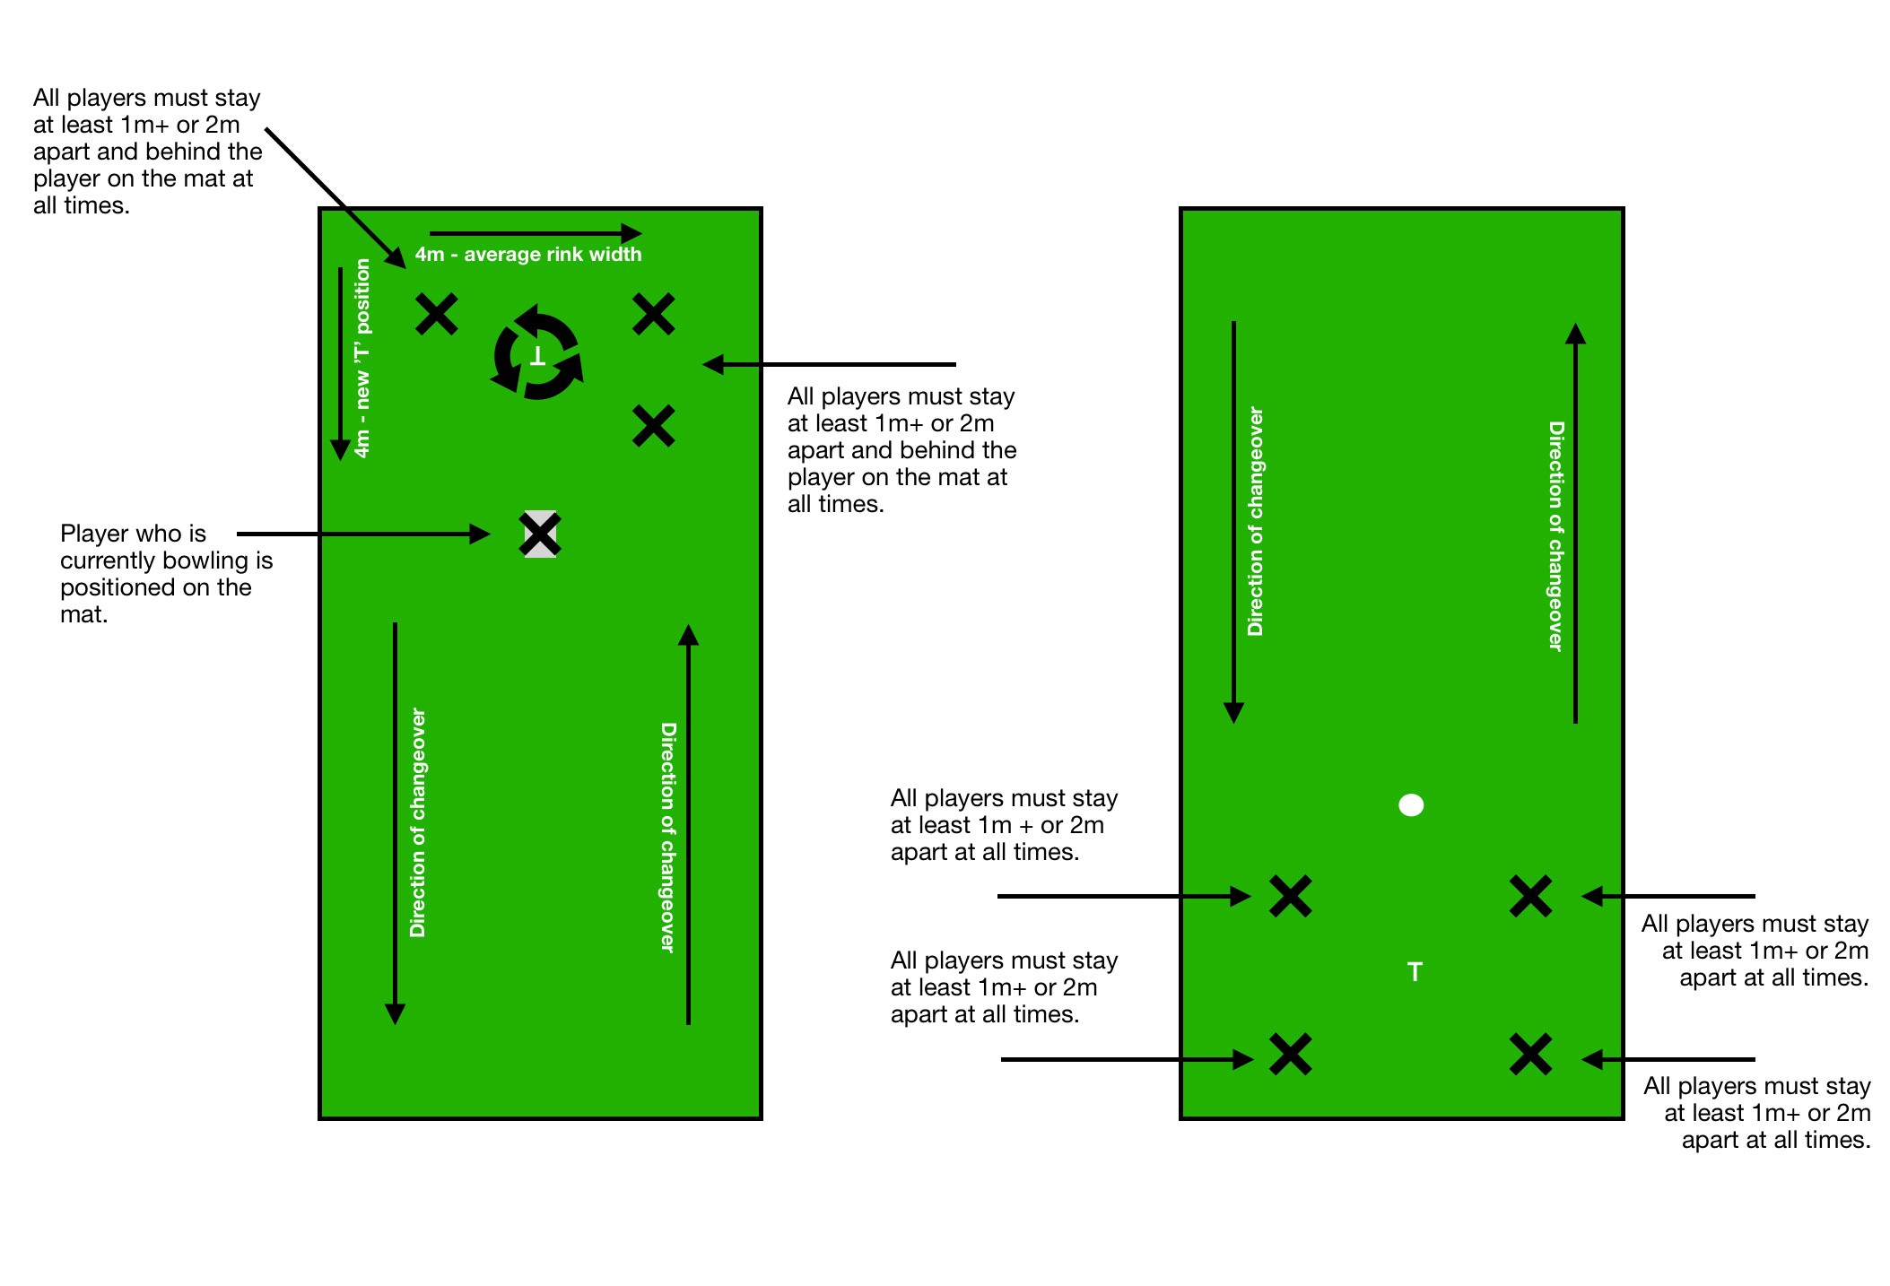

Appendix Three

‘T’ moved

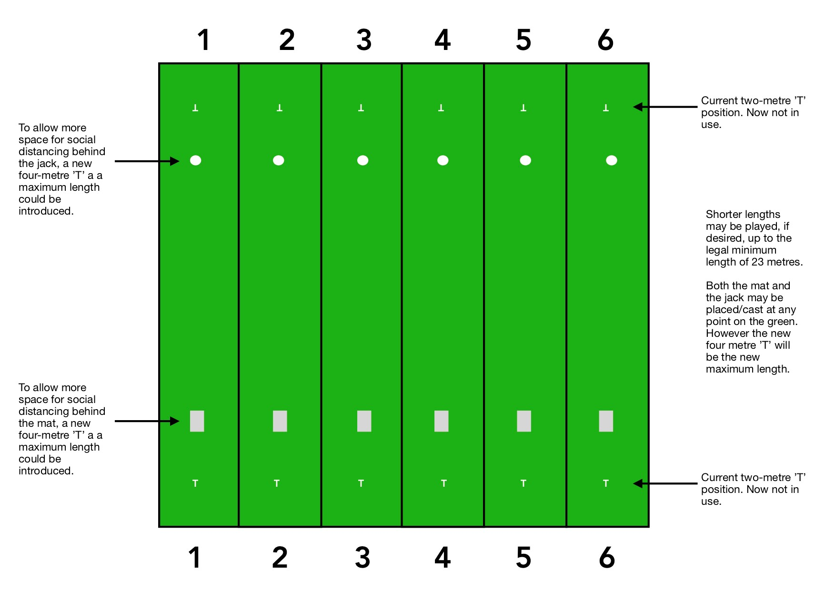

Appendix Four
Bar / Restaurant Check
This checklist is designed to assist Clubs who do wish to reopen their bar and restaurant area – it is not an exhaustive list and some of the items highlighted within may not be relevant to your club.

We recommend that you tailor this checklist to meet your club’s individual requirements.

- Capacity, signage, spacing and movement
 | Relevant | Completed
Consider maximum capacity for all areas based upon social distancing requirements and means of managing capacity (e.g. time limits for length of stay)
Establish a mechanism to collect contact details for all entering the clubhouse and to store the data for 21 days. Ensure compliance with GDPR in collection and storage of details
Ensure all seating areas (indoor and outdoor) are sufficiently spaced and enable movement of people whilst maintaining appropriate social distancing
Consider the safe movement of people and queueing mechanism for access and service – including implementing one-way systems and bar areas
Provide clear signage throughout the facility to guide and inform members and visitors, including any mandatory signage according to government regulations
Enable cashless payment for any services you are able to provide within government guidelines
Consider whether to have a member of staff or volunteer at the entrance to manage the number of people in the clubhouse at one time

- Food and beverages
 | Relevant | Completed
Introduce a limited menu with items quick to produce to limit service time and queueing
Consider how social distancing can be maintained for staff and/or volunteers
Remove any non-essential objects that users may touch
Provide only single-use condiments
Ensure cleaning and sanitisation of glasses and crockery are appropriate
Provide training for staff and/or volunteers to ensure knowledge and understanding of their responsibilities for maintaining cleanliness and sanitisation
Ensure compliance with food standards by checking use by dates on all produce
Check cellar for CO2 leaks and open cellar door and delivery hatches to change the atmospheric air in the cellar (in case of CO2 leaks)
Clean beer lines
Check for signs of rodent or insect infestation

- Hygiene and Sanitation

 | Relevant | Completed
Ensure hand-sanitiser is available at appropriate points and that stock levels are sufficient to regularly replenish
Ensure all soap dispensers are full and that stock levels are sufficient to regularly replenish
Ensure paper towels are available and that stock levels are sufficient to regularly replenish
Regularly clean and sanitise all hard surfaces
Wedge doors open to avoid the need to touch door handles, where possible
Provide ventilation to the building by opening windows and doors, where possible

- Fire-related

 | Relevant | Completed
Check the emergency lighting and fire alarm are operational and that the fire panel is not flagging up any problems
Review and, if necessary, update building evacuation plans to support appropriate social distancing
Check all evacuation routes are clear, unlocked and operational
Visually check fire extinguishers - look for leaks and ensure gauges are pointing to full

- Plant-related

 | Relevant | Completed
Check kitchen gas auto-safe valve is operational
Check mains fuse board for tripped RCDs, both before and after turning on bulk of electrical appliances
Check door locks and windows for signs of forced entry
Check heating is fully operational
Ensure ladies feminine hygiene bins are empty

- Water system-related

 | Relevant | Completed
Follow and implement your locally agreed L8 (control of Legionella bacteria in water systems) safety measures to flush though and disinfect all water outlets
Regularly clean and disinfect sinks, toilets etc.
Flush and clean all toilets
Check building for signs of water leaks - especially older clubhouse buildings

